The Holocaust Study Day

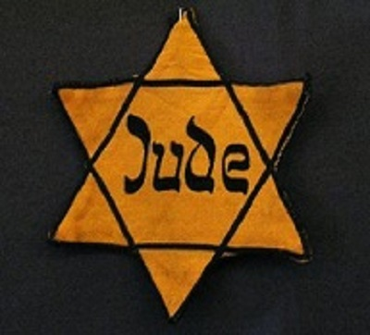
Saturday 04 June 2016
10.00-16:00
Lecture Theatre B, Building 65
Avenue Campus
10:00 | Coffee and Welcome
10:10 | Jean Amery’s The Intellectual in Auschwitz  Andrea Reiter, University of Southampton  It is sometimes claimed that the intellectual who could focus his mind on something beyond the harsh reality of the concentration camp had a better chance of survival than other inmates. Jean Améry, an Austrian Jew who survived Auschwitz, disputes this assertion in his memorable autobiographical essay on torture.  Inter alia this session will focus on the aporia of “speaking the unspeakable” and its function as a facilitator in autobiographical Holocaust literature.  Questions addressed in this session include the following: How does Jean Améry talk about his camp experience? What does he say and, more importantly, what does he not say? What impact does this have on the reader’s imagination?
10:55 | Perpetrator and victim: anti-Semitism in the province, 1933  Christine Lattek, University of Southampton  Centred on a local case study of early anti-Semitic measures taken by the Nazis immediately after their 'seizure of power', the talk focuses on the wider context of debates about victim and perpetrator identities but also on the repercussions in contemporary German memory culture.
11:40 | Coffee
12:00 | I am a Jew (1940): An Early Holocaust Play on the BBC  James Jordan, University of Southampton  This talk will discuss I am a Jew (1940), broadcast on the Home Service in 1940 and the first BBC play to confront the persecution of European Jewry. ‘Concentration camps and suicides may not make for bright listening,’ wrote the Radio Times, ‘but it is unlikely that many listeners will remain unmoved by this tragic, dramatic statement.’
12:45 | Lunch
13:45 | The legacy of the Holocaust in Jewish-American literature  Mike Witcombe, University of Southampton  What do we talk about when we talk about Anne Frank?  This is the title of a recent short story collection by a Jewish-American writer, itself raising an important question: how have American Jews responded to the Holocaust? To answer this question, we will both analyse general themes in literary history and spend time focusing on some books in detail. In particular, we will study the issues surrounding the publication of Cynthia Ozick's novella The Shawl, and then look at how Anne Frank herself has been reinterpreted by the best-selling writers Philip Roth and Shalom Auslander."
14:30 Coffee

15:35 Closing remarks

16:00 End of Day

